Credit Card Default Prediction.

Shivaprasad Sagar Gunti
Department Of Computer Science
Lawrence Technological University
Southfield,Michigan-48034 Email- sgunti@ltu.edu

Step by step implementation and explanation of the program.

1.

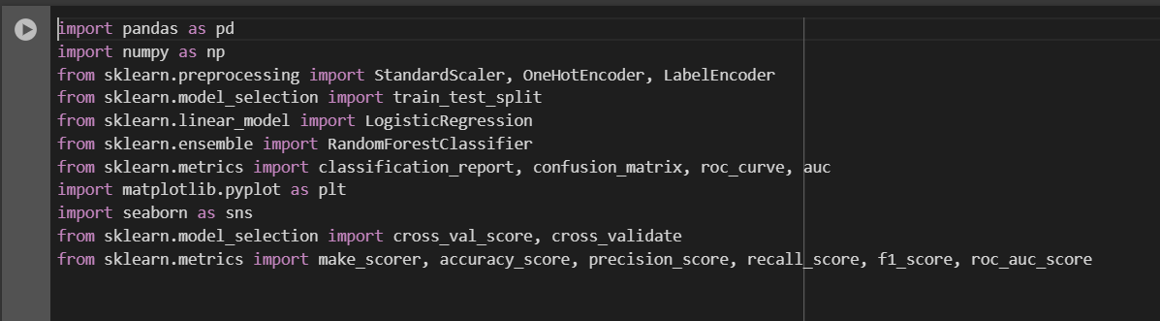
Importing all the necessary libraries for the Machine Learning program.
2.
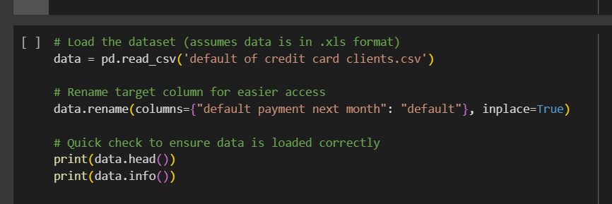

Code explanation:
Here we are loading the dataset and renaming the target column to default for easy understanding.
Checking the loaded data whether the data is loaded correctly or not.

Output:
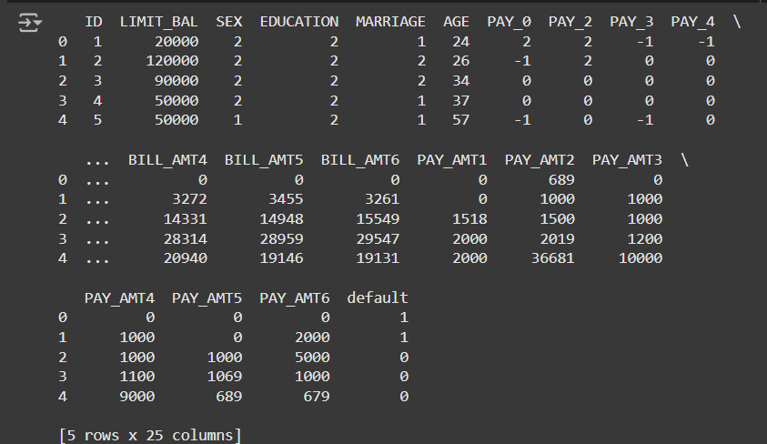

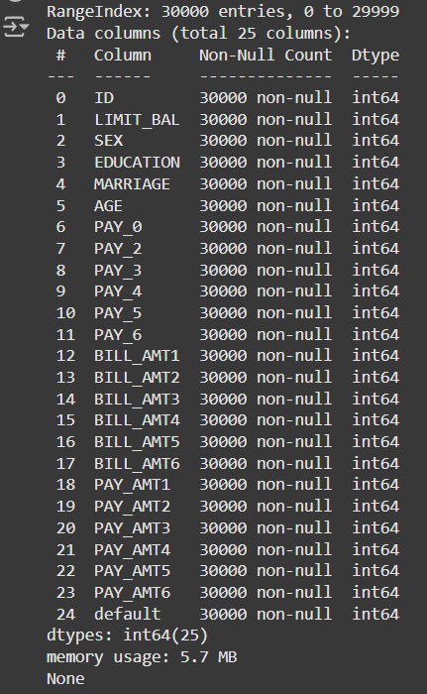

3.
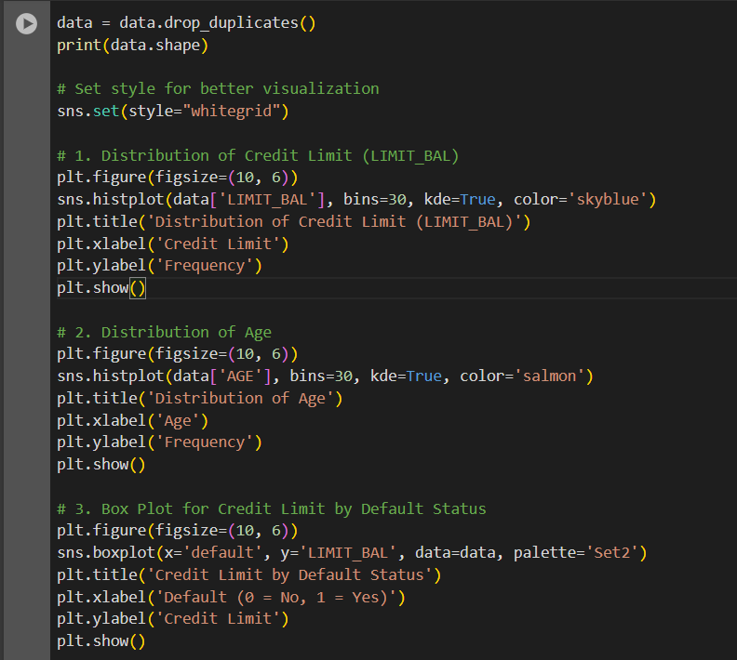
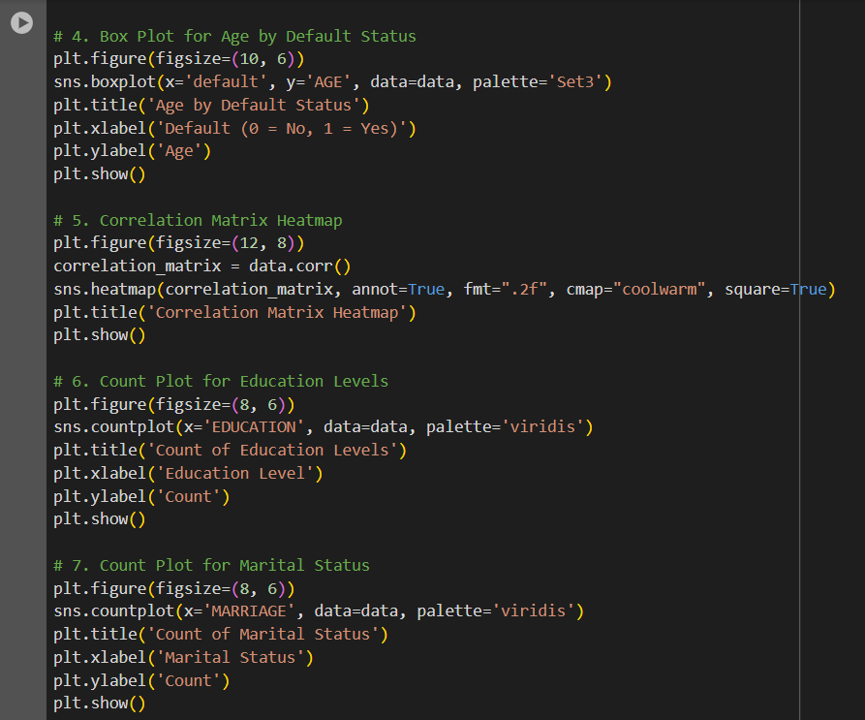
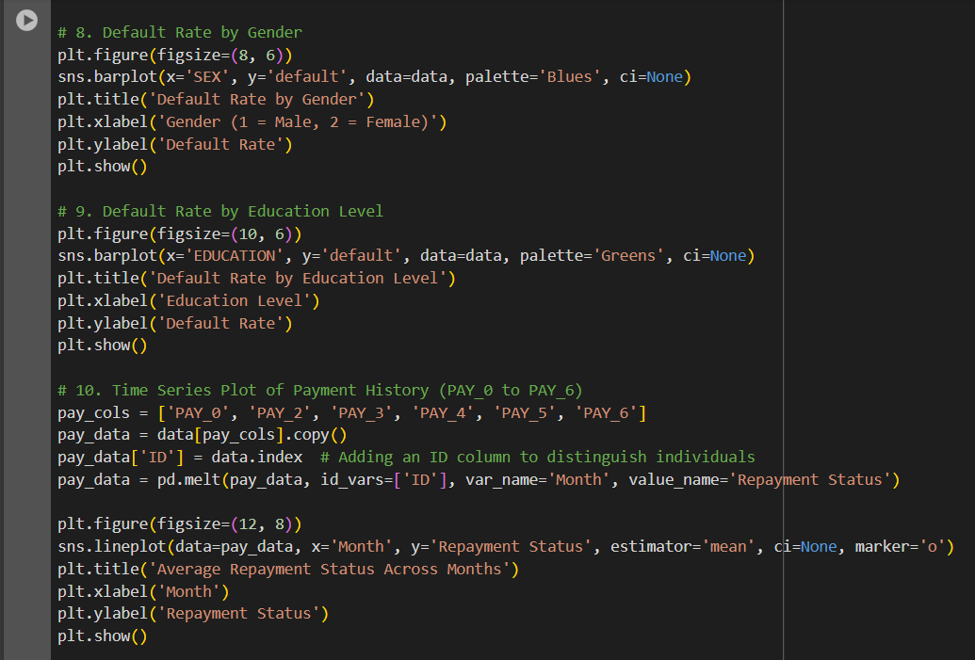

Code explanation:
data.drop_duplicates() removes any duplicate rows in the dataset.
print(data.shape) outputs the shape (rows, columns) of the cleaned dataset.
Sets Seaborn’s plot style to "whitegrid" for improved readability of visualizations.

We are visualizing various attributes in the data for the better understanding.

Heatmap shows the correlations between numerical columns in the dataset.
Helps identify strong positive or negative relationships between features.

Output:
Data shape (30000, 25)

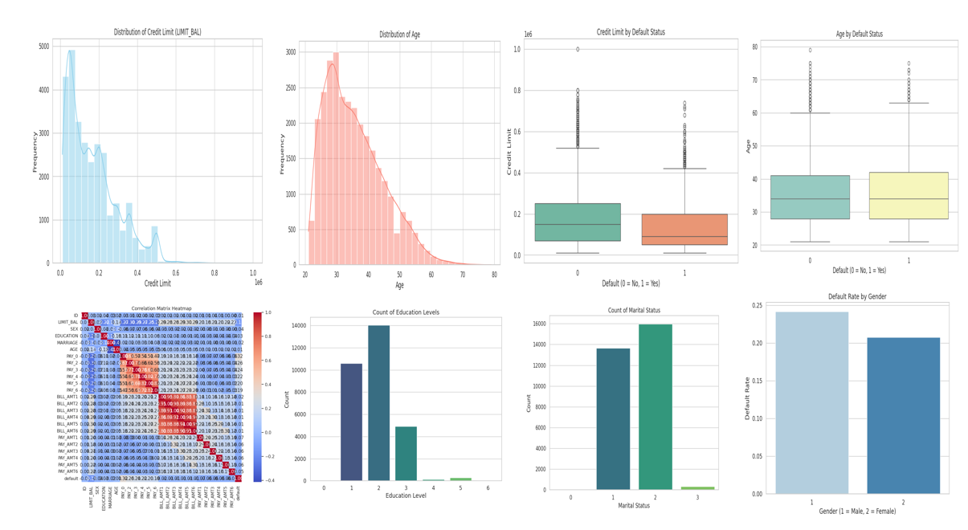

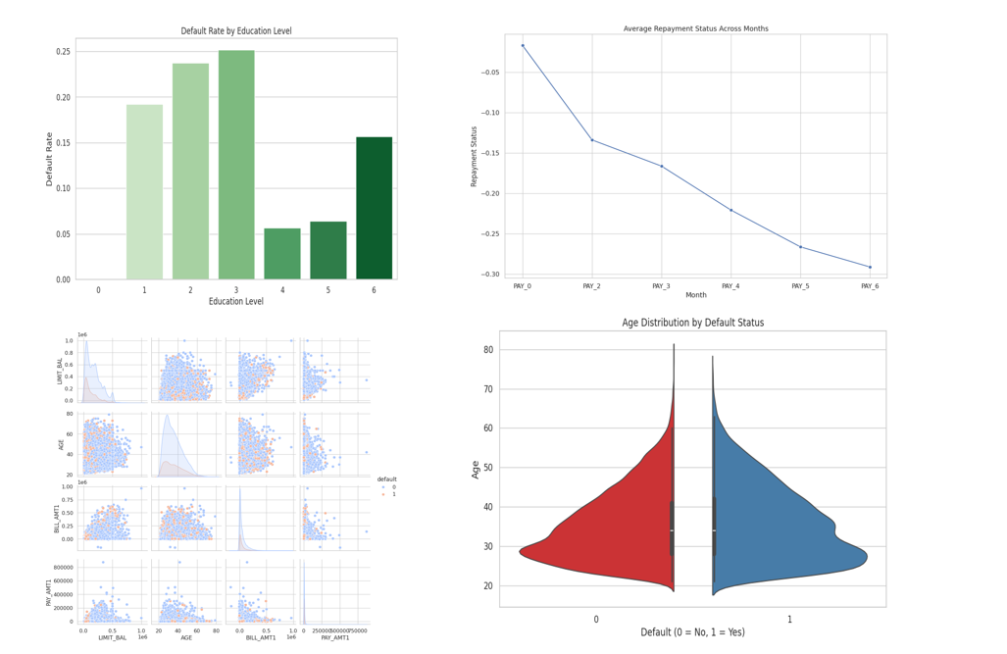

4.
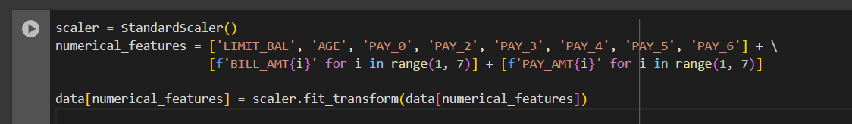
Code explanation:
This code snippet scales a set of numerical features in a dataset using Standard Scaler from scikit-learn, which standardizes features by removing the mean and scaling to unit variance (z-score normalization).
Scaler.fit_transform(data[numerical_features]) standardizes each feature in numerical_features.
Replaces the original columns in data with their scaled values.
This standardization ensures that each numerical feature has a mean of 0 and a standard deviation of 1, which can improve the performance of many machine learning models by making the features comparable in scale.

5.
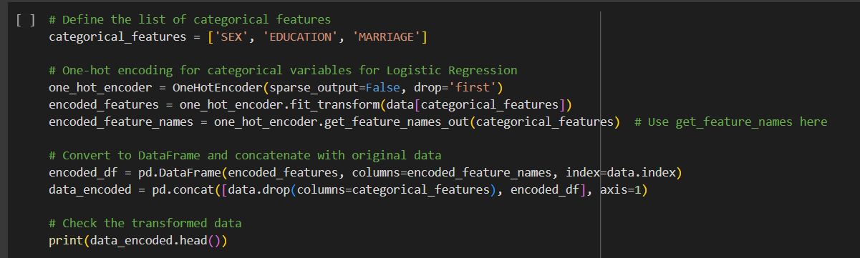

Code explanation:
This code prepares categorical features for a machine learning model by applying one-hot encoding, which is particularly useful for algorithms like logistic regression that need numerical inputs.

Defining Categorical Features:
The code begins by identifying which columns in the dataset contain categorical data (in this case, gender, education, and marital status) that need to be transformed.

One-Hot Encoding:
A one-hot encoder is initialized to convert each category in these features into a binary format. This encoder is configured to output a dense (non-sparse) array, and it uses “dummy encoding” by dropping the first category in each feature. This technique reduces multicollinearity, which can improve model stability in logistic regression. The encoder is then applied to the categorical features, creating new binary columns to represent each unique category in the data.

Converting and Concatenating with the Original Data:
The transformed binary data is converted into a new Data Frame, which includes appropriate column names for easy identification. This new Data Frame is then merged back with the original dataset after removing the original categorical columns. The result is a transformed dataset with only numerical columns, ready for modeling.

Verifying the Transformation:
Finally, the first few rows of the transformed dataset are printed to verify that the one-hot encoding was applied as expected. This step ensures that the data is now in a suitable format for training a logistic regression model, or any other model that requires numerical input.

Output:
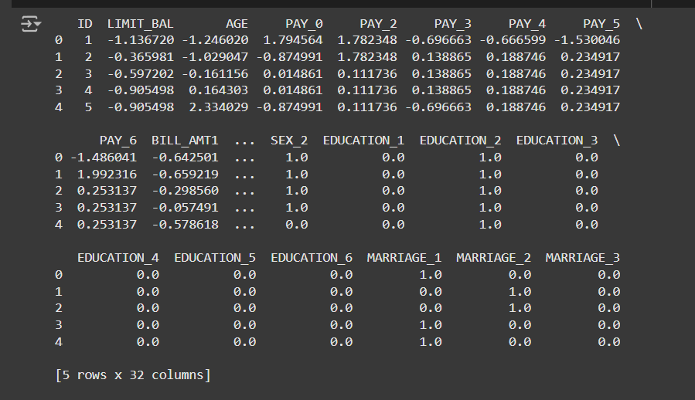

6.
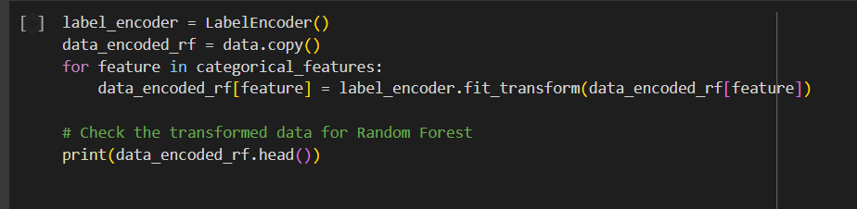

Code explanation:
Categorical features for a machine learning model, specifically for a Random Forest model, by applying label encoding.
Setting Up the Encoder:
A label encoder is initialized to transform categorical values into numerical values. Unlike one-hot encoding, label encoding assigns a unique integer to each category in a feature, which is efficient for tree-based models like Random Forests that don’t require dummy variables for categorical inputs.
Copying the Data:
A copy of the original dataset is made to avoid modifying it directly. This ensures the original data remains intact and unaffected by the encoding process.
Applying Label Encoding:
The code iterates over each categorical feature, applying the label encoder to transform the categories into integer values. Each unique category in a feature is assigned a distinct integer. This process converts all categorical features into a numerical format compatible with the Random Forest model.
Checking the Result:
Finally, the first few rows of the transformed dataset are displayed to confirm that the label encoding was successful. The transformed dataset now has categorical features represented as integers, which is suitable for use in the Random Forest model, as it can effectively handle integer-encoded categorical data.

Output:

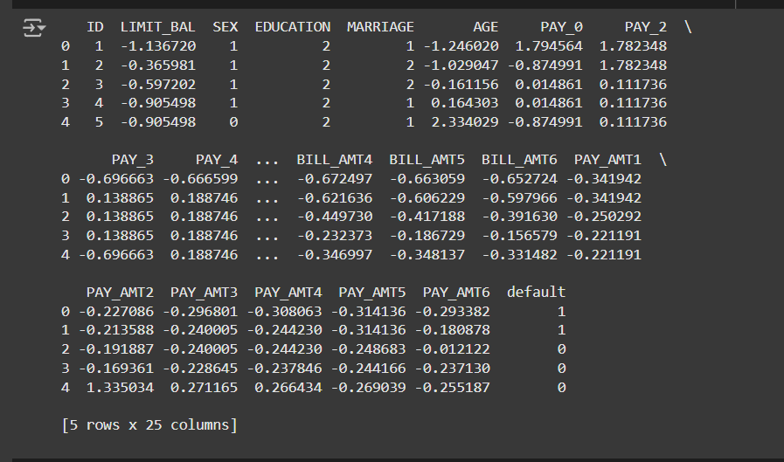

7.
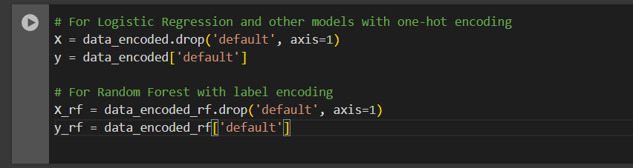
This prepares separate feature (X) and target (y) variables for different machine learning models.
For Logistic Regression and Models with One-Hot Encoding:
The dataset created with one-hot encoding is used to prepare the features (X) and target (y). The target variable, which indicates whether a customer has defaulted or not, is selected as y. The remaining columns are selected as X by dropping the target column. This setup is suitable for logistic regression and other models that require one-hot encoded data.
For Random Forest with Label Encoding:
For Random Forest, the label-encoded dataset is used. Similar to the one-hot encoding approach, the target variable is separated as y_rf, while the remaining columns are kept as X_rf by dropping the target column. Random Forest can handle label-encoded data effectively, making this setup appropriate for tree-based models.
By separating features and targets in this way, the code prepares the data for training on different models based on their encoding requirements.

8.
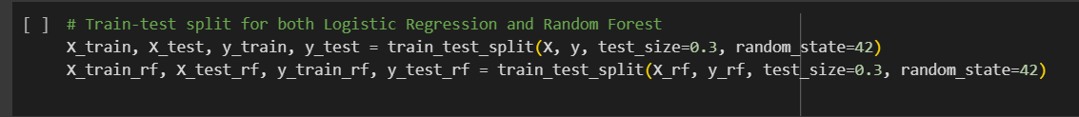

Code explanation:
Performs a train-test split for both datasets, one prepared for logistic regression and one for Random Forest, dividing them into training and testing subsets.

For each dataset, the features (X and X_rf) and target variables (y and y_rf) are split into training and testing sets. The split allocates 70% of the data for training and 30% for testing, ensuring a balanced partition for model evaluation. A fixed random seed (random_state) is set to 42 for reproducibility, so that the split remains consistent each time the code is run.
By creating separate train-test splits for both logistic regression and Random Forest, this code ensures that each model has its own training and testing data, prepared according to its requirements. This setup allows independent training and evaluation for both models on compatible datasets.

9.
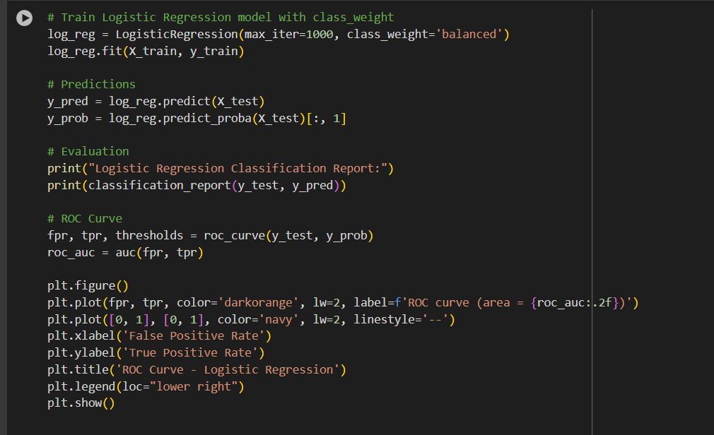

Code explanation:
This code trains and evaluates a logistic regression model, along with generating a performance metric and an ROC curve.
Training the Model:
A logistic regression model is initialized with balanced class weights to handle any imbalance in the dataset. This weight adjustment helps the model give equal importance to each class. The model is then trained on the training data.
Making Predictions:
After training, the model predicts the class labels for the test data, as well as the probabilities of each class. The probabilities are specifically useful for evaluating the model on metrics like the ROC curve.
Evaluating the Model:
The code prints a classification report, which provides key performance metrics like precision, recall, and F1-score for each class. This report gives a summary of the model's predictive accuracy and how well it distinguishes between classes.
Generating the ROC Curve:
The code calculates the false positive rate (FPR) and true positive rate (TPR) for different threshold values using the test data and the predicted probabilities. These rates are used to plot the ROC curve, which shows the model's ability to separate the classes. The area under the ROC curve (AUC) is also computed as a summary metric of model performance, where a higher AUC indicates better performance.
Plotting the ROC Curve:
A plot is created for the ROC curve, showing the trade-off between the true positive rate and false positive rate at various threshold settings. A diagonal line representing random guessing is included for comparison. The ROC curve visually indicates the model's classification power, with the AUC displayed as part of the legend.

Output:

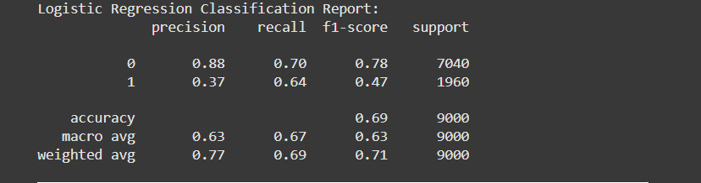
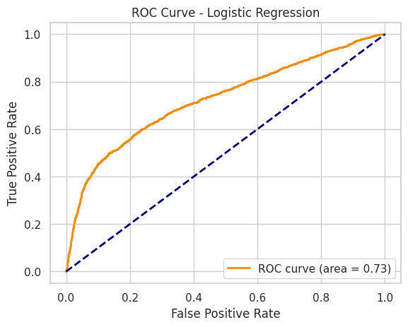

10.
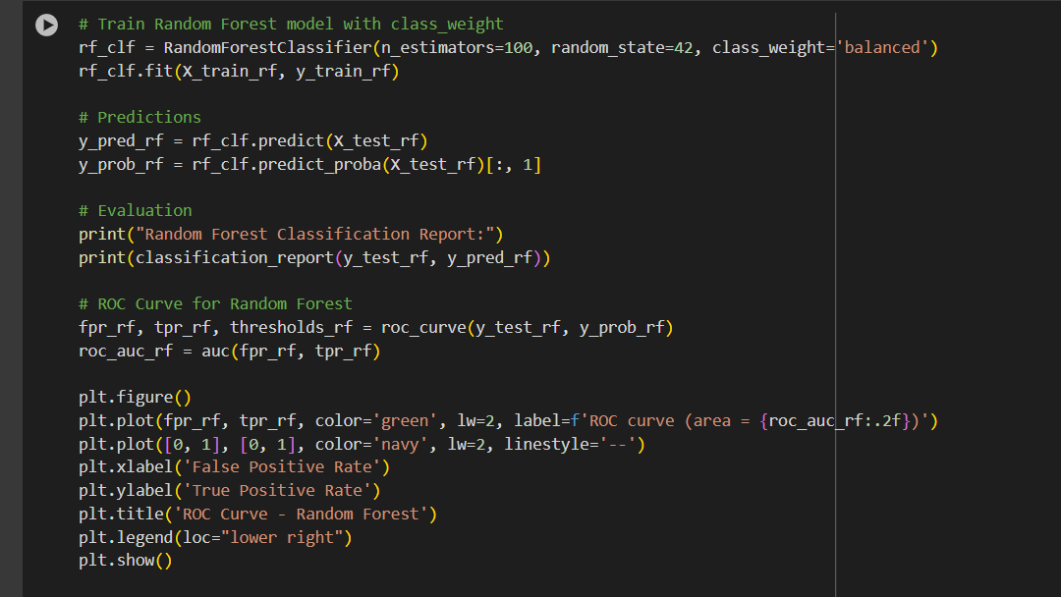

Code explanation
This code trains, evaluates, and visualizes the performance of a Random Forest model on a classification task.
Training the Model:
A Random Forest classifier is initialized with specific parameters, including a balanced class weight to handle any class imbalance. This weight adjustment ensures that each class is considered equally during training. The model is trained using the training data, with 100 decision trees specified in the ensemble.

Making Predictions:
After training, the model is used to predict class labels for the test set. Additionally, it outputs the predicted probabilities for each class, which are used to evaluate the model's performance on metrics like the ROC curve.
Evaluating the Model:
A classification report is generated, providing detailed metrics such as precision, recall, and F1-score for each class. This report helps assess the Random Forest model's effectiveness in distinguishing between classes.
Generating the ROC Curve:
Using the predicted probabilities, the code calculates the false positive rate (FPR) and true positive rate (TPR) for different threshold values. These values are used to plot the ROC curve, which illustrates the model's ability to separate the classes across various thresholds. The area under the ROC curve (AUC) is computed, where a higher AUC indicates better model performance.
Plotting the ROC Curve:
The ROC curve is plotted, showing the trade-off between the true positive rate and false positive rate at different threshold levels. A diagonal line representing random chance is added for comparison. The AUC score is displayed in the plot legend, providing a quick visual summary of the model's discriminative power.

Output:
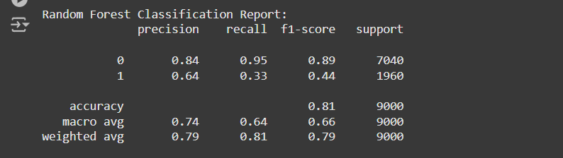
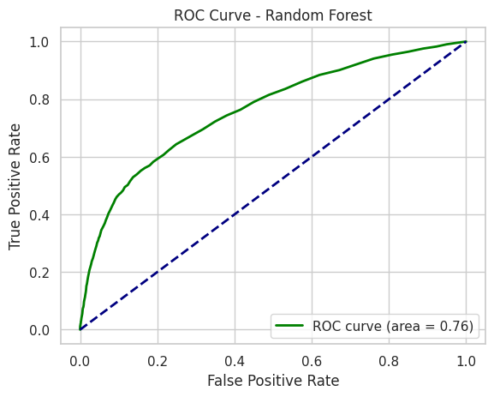

11.
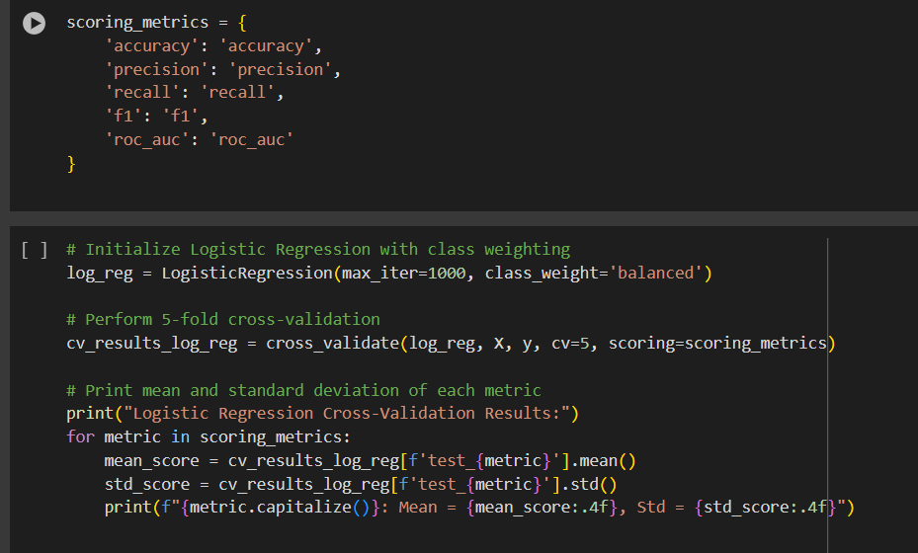
Code explanation:
This performs 5-fold cross-validation on a logistic regression model, evaluating it on multiple performance metrics.
Defining Scoring Metrics:
A dictionary of scoring metrics is defined, specifying accuracy, precision, recall, F1-score, and AUC (Area Under the ROC Curve). These metrics provide a comprehensive evaluation of the model's performance from different perspectives.
Initializing the Logistic Regression Model:
A logistic regression model is created with class weights set to 'balanced' to account for any imbalance in the dataset. This ensures that both classes are treated fairly during training.
Performing Cross-Validation:
The model undergoes 5-fold cross-validation. In this process, the dataset is split into five subsets, and the model is trained and evaluated five times, each time using a different subset as the test set while training on the remaining four. This approach provides a robust assessment of the model’s performance and reduces the risk of overfitting to any single subset.
Calculating and Printing Results:
For each metric, the mean and standard deviation across the five folds calculated and printed. The mean indicates the average performance of the model across all folds, while the standard deviation shows the variability in performance, providing insight into the model’s consistency.
This process yields a reliable estimate of how the logistic regression model is likely to perform on unseen data, using multiple metrics to capture different aspects of classification quality.

Output:
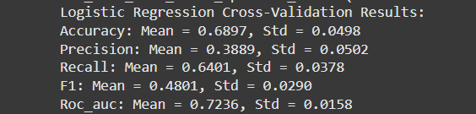

12.
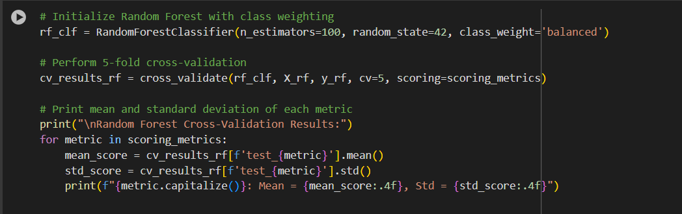

Code explanation:
This performs 5-fold cross-validation on a Random Forest model and evaluates it using multiple metrics.
Initializing the Random Forest Model:
A Random Forest classifier is set up with 100 decision trees and balanced class weights to handle any class imbalance in the data. This ensures that each class is given equal importance in the model training. A fixed random seed is also used to ensure reproducibility.
Conducting Cross-Validation:
The model is evaluated using 5-fold cross-validation, where the data is split into five subsets. The model is trained and evaluated five times, with each subset serving as the test set once. This approach provides a reliable measure of the model's performance across different parts of the data, reducing the likelihood of overfitting to any specific subset.
Calculating and Displaying Results:
For each evaluation metric—accuracy, precision, recall, F1-score, and AUC—the code calculates the mean and standard deviation across the five folds. The mean score indicates the model’s average performance for each metric, while the standard deviation shows the variability across folds, providing insight into the model’s consistency.
This cross-validation process yields a well-rounded evaluation of the Random Forest model, capturing various performance metrics that give a complete picture of its classification effectiveness.

Output:
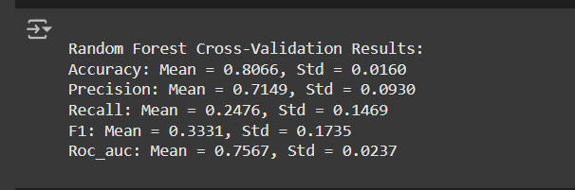

13.
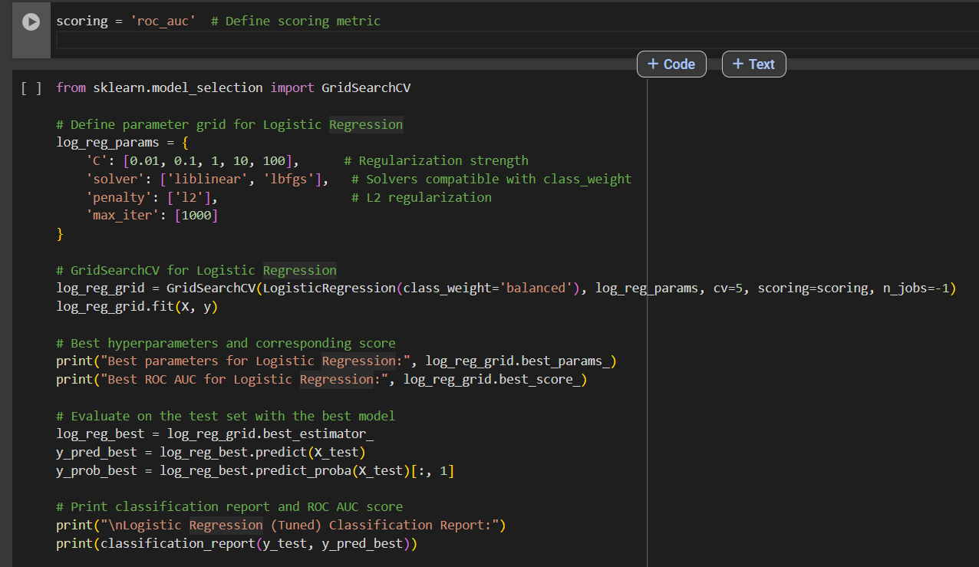
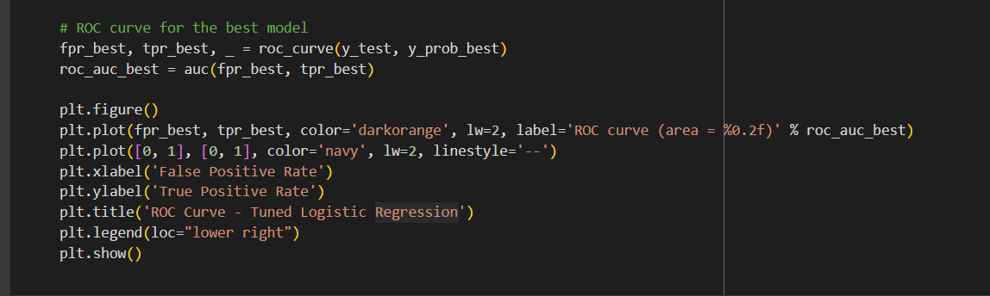

Code explanation:
This performs hyperparameter tuning on a logistic regression model using GridSearchCV and evaluates the optimized model.
Defining the Parameter Grid:
A grid of hyperparameters for logistic regression is specified. This includes a range of regularization strengths (C values), solver options (such as liblinear and lbfgs), a regularization penalty (L2), and a maximum number of iterations. These parameters will be tested to find the best configuration for the model.
Setting Up and Running Grid Search:
GridSearchCV is initialized to conduct a grid search over the specified hyperparameter combinations using 5-fold cross-validation. The scoring metric for the search is set to ROC AUC, which measures the area under the ROC curve, a common metric for classification tasks. The search is executed on the training data to identify the best hyperparameter combination.
Retrieving the Best Parameters and Score:
After the grid search completes, the best hyperparameters are extracted, along with the highest ROC AUC score achieved during cross-validation. This indicates the optimal parameter configuration for the logistic regression model.
Evaluating the Best Model on the Test Set:
The best logistic regression model from the grid search is applied to the test set to generate predictions and probability scores. This step assesses the model's performance on unseen data, using the optimal hyperparameters identified during training.
Printing the Classification Report and ROC AUC Score:
A classification report is generated, providing metrics like precision, recall, and F1-score for each class. The ROC AUC score is also printed to evaluate the model's ability to distinguish between classes on the test set.
Plotting the ROC Curve:
The ROC curve is plotted for the best model, showing the trade-off between the true positive rate and false positive rate across different thresholds. The area under the ROC curve (AUC) is displayed in the legend, offering a quick summary of the model's classification performance.
Overall, this code optimizes the logistic regression model through hyperparameter tuning, then evaluates and visualizes its performance on the test data. This process helps ensure that the model achieves the best possible performance for the given dataset.

Output:
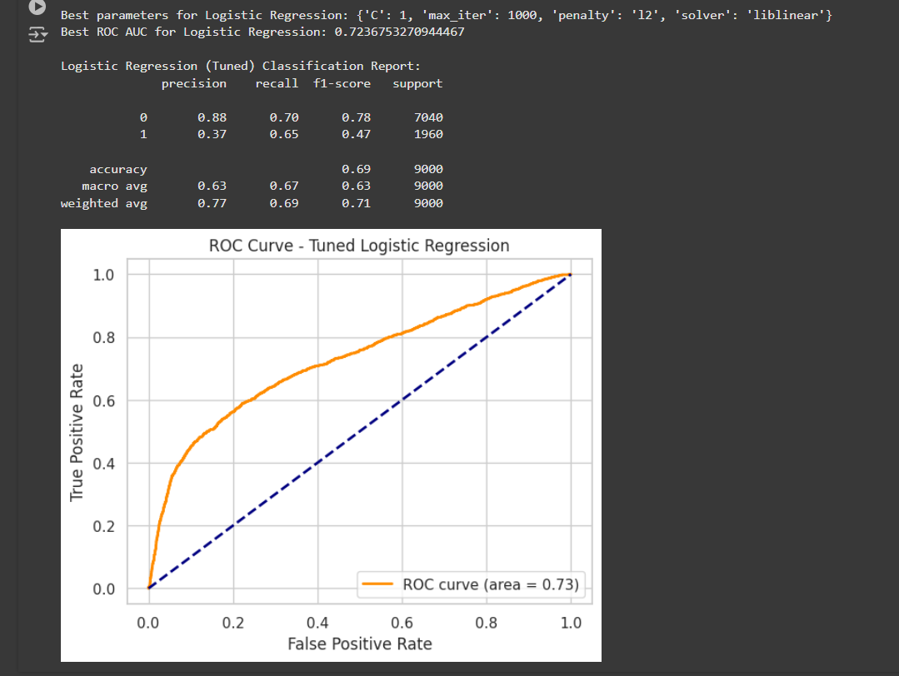

14.
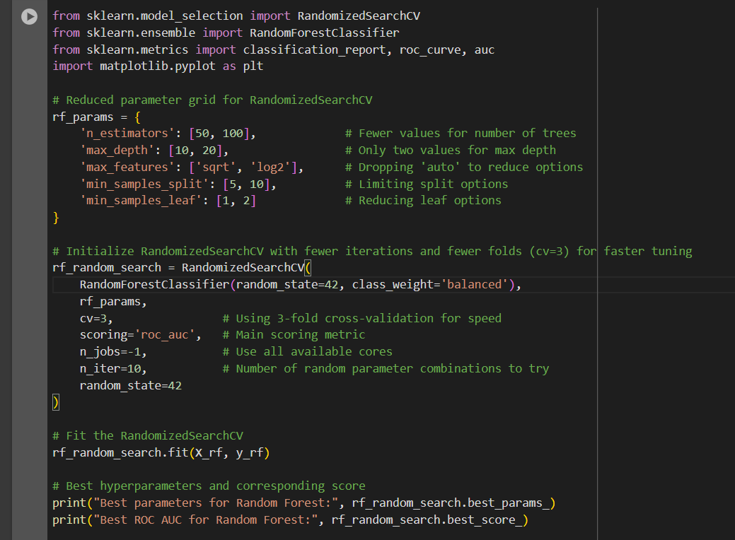
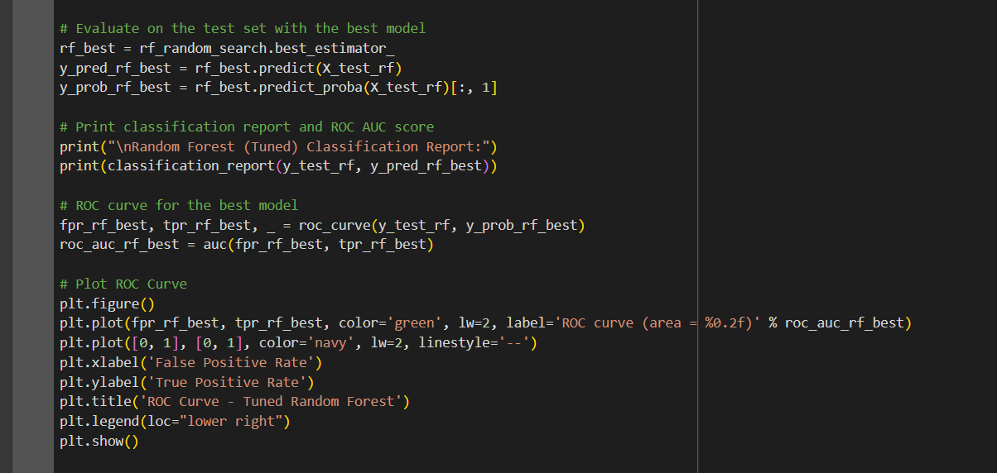

Code explanation:
This performs hyperparameter tuning on a Random Forest model using RandomizedSearchCV, then evaluates and visualizes the optimized model.
Defining the Parameter Grid:
A reduced set of hyperparameters for the Random Forest model is specified. This grid includes different values for the number of trees, maximum depth of trees, maximum number of features considered at each split, minimum samples required to split an internal node, and minimum samples required to form a leaf node. Using a limited set of options speeds up the search and makes it more efficient.
Setting Up and Running Randomized Search:
RandomizedSearchCV is used for hyperparameter tuning. Unlike grid search, which tests all possible combinations, randomized search tests a fixed number of randomly chosen parameter combinations. This approach is faster and often effective for complex models like Random Forests. The search is performed with 3-fold cross-validation and the ROC AUC metric as the scoring criterion.
Training and Extracting the Best Parameters:
The randomized search is fitted to the training data, and the best combination of hyperparameters is extracted. The highest ROC AUC score achieved during cross-validation is also printed, indicating the best model’s performance on the training set.
Evaluating the Best Model on the Test Set:
The best model from the search is used to predict the test set’s class labels and probabilities. This allows an evaluation of the model's effectiveness on unseen data, using the optimal parameters identified during training.
Printing the Classification Report and ROC AUC Score:
A classification report is generated, providing metrics like precision, recall, and F1-score for each class. The ROC AUC score is also printed, offering a comprehensive measure of the model’s ability to separate the classes on the test data.
Plotting the ROC Curve:
The ROC curve is plotted to visualize the trade-off between the true positive rate and false positive rate at different threshold levels. The area under the ROC curve (AUC) is displayed in the legend, summarizing the model’s performance.
This process optimizes the Random Forest model using randomized search, providing a quicker alternative to exhaustive grid search, and evaluates the tuned model to ensure its robustness and effectiveness on new data.

Output:
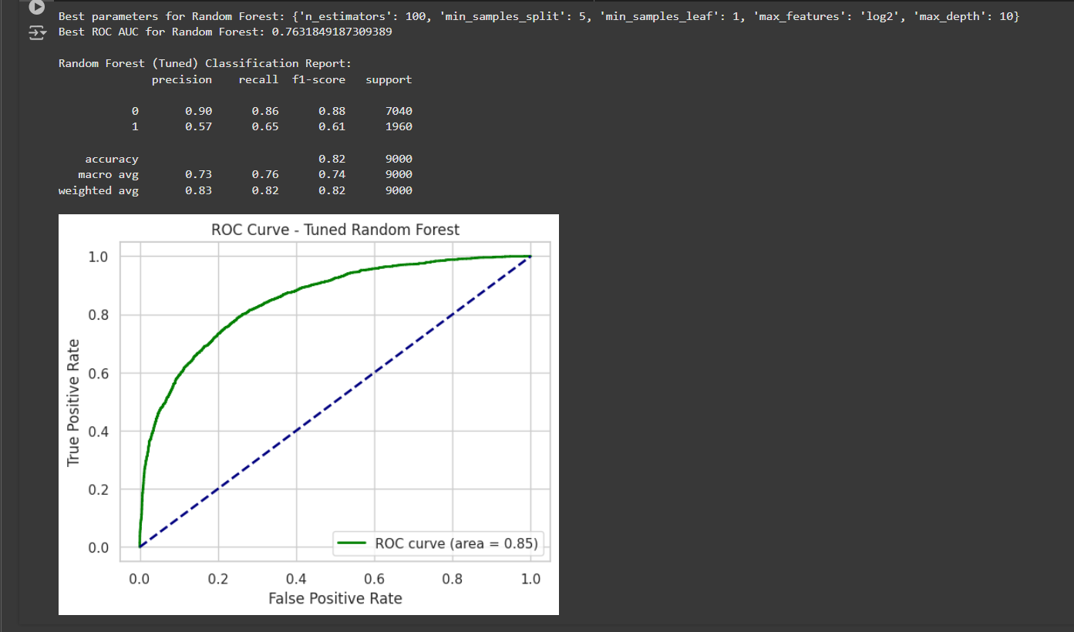

15.
pip install gradio – To use gradio in the program.
This command installs Gradio, a Python library for creating simple web-based interfaces for machine learning models and other functions.

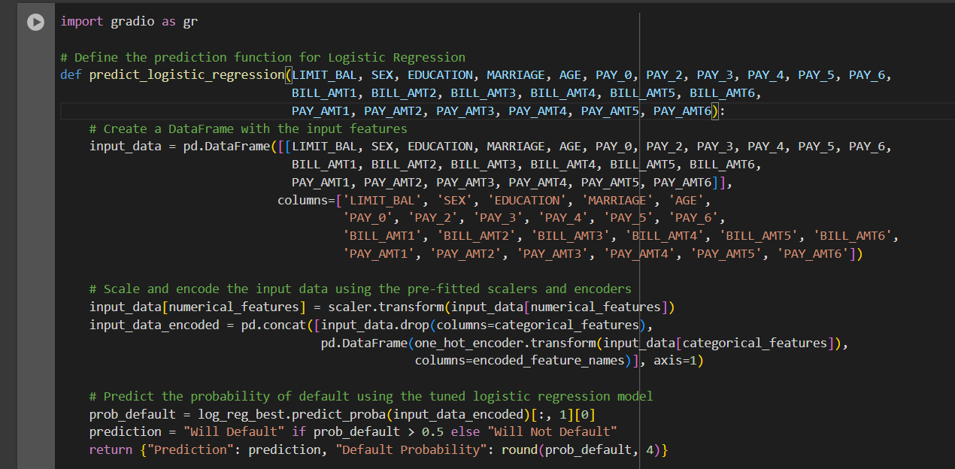
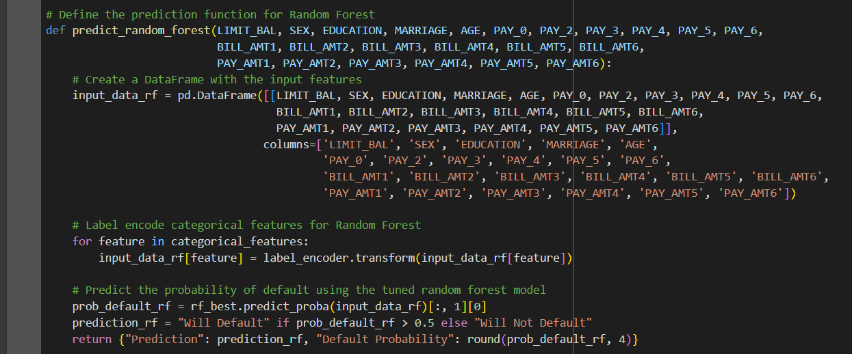
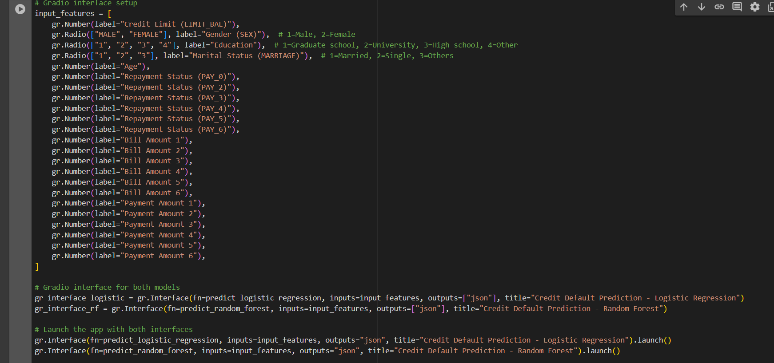

Code explanation:
This code creates an interactive interface using Gradio for predicting credit default probability with both logistic regression and random forest models. The Gradio interface provides input fields for users to enter feature values and receive predictions about whether a customer is likely to default.
Defining Prediction Functions for Each Model:
The code defines two separate prediction functions—one for logistic regression and one for random forest. Each function takes input features such as credit limit, gender, education, marital status, age, repayment status, bill amounts, and payment amounts. The input data is organized into a DataFrame for processing.
Scaling and Encoding Input Data:
For logistic regression, input data is scaled and one-hot encoded to match the format used during training. For random forest, categorical features are label-encoded, as random forest models can handle integer-encoded categorical variables directly. These transformations ensure that the input format matches the model’s expected input.
Making Predictions and Preparing Output:
Each function uses the tuned model to predict the probability of default based on the input data. The output is a JSON-like dictionary indicating whether the customer is predicted to "Will Default" or "Will Not Default" and providing the default probability.
Setting Up Gradio Interface Components:
A Gradio interface is set up with labeled input fields that correspond to each feature required by the models. Fields include text inputs, sliders, and radio buttons to allow users to input various data points, such as credit limit, repayment statuses, bill amounts, and payment amounts.
Launching the Interface:
The Gradio interface is configured to display separate panels for logistic regression and random forest predictions. Each model’s prediction function is assigned to an interface component that displays the results in JSON format, including both the prediction label and probability.
This Gradio interface enables users to interactively input data and receive real-time credit default predictions from both models, making the model outputs accessible and understandable for non-technical users.

Output:

Logistic regression
URL: https://3d2e51b34d93ad53db.gradio.live
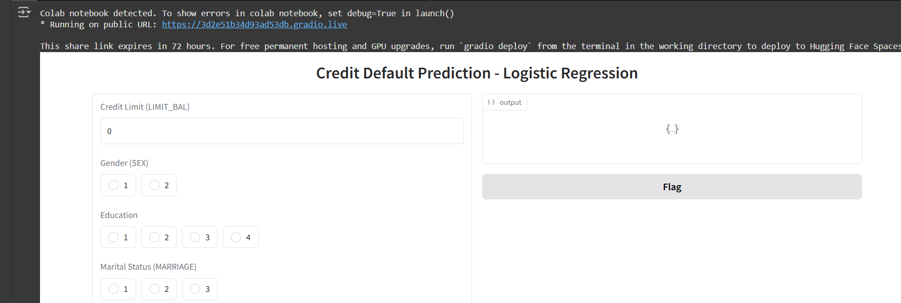

Random Forest
URL: https://ef7e742f04322c70b2.gradio.live

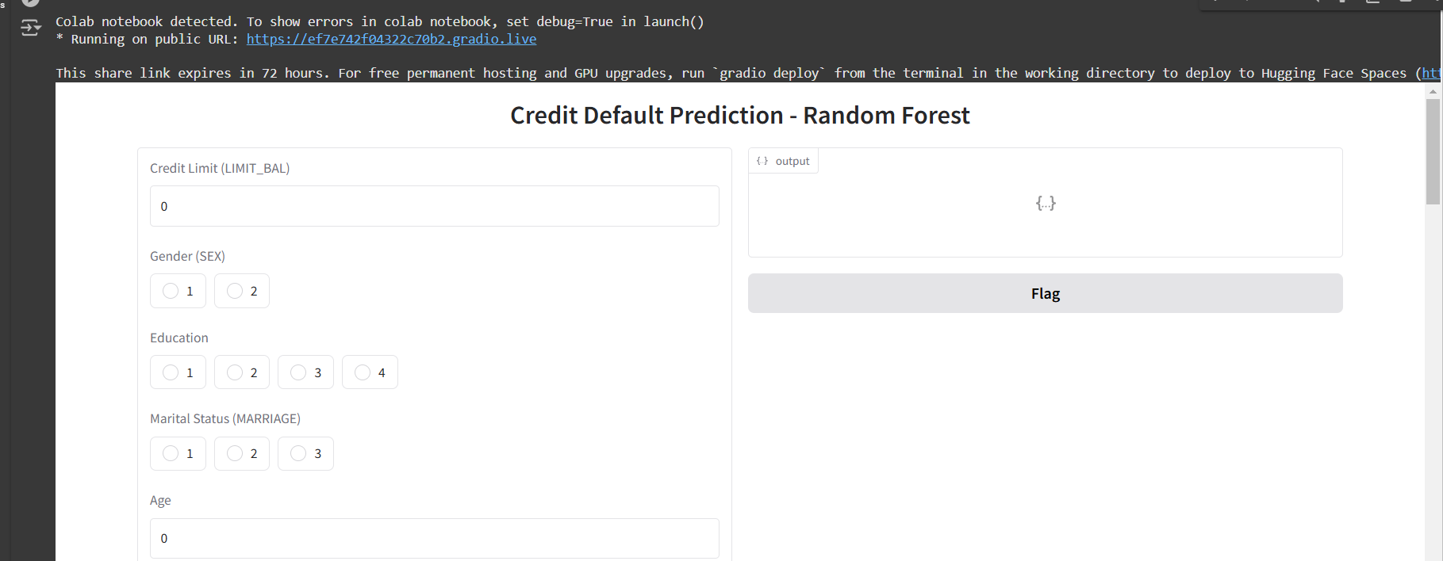

GITHUB:
https://github.com/shivaprasad444/Credit-Card-Default-Prediction.

